Observers: T. Lavictoire Survey Results: STOC Pair and 2 Juveniles Found
Mountain Range: Chiricahua
Quad map name(s): Chiricahua Peak, AZ General Habitat: Mixed Conifer/Oak
Visit#: DS2
Sunrise or Sunset Time: 1925
Times For: | Start (24-hr) | End (24-hr) | Total  (~ ¼ hour)
Hike-in: | 1825 | 1909 | 0.75
Survey: | 1909 | 2020 | 1.25
Hike-out: | 2035 | 2120 | 0.75
Weather: | Survey
Weather: | Start | End
Wind (range mph): | 8-12 | 8-12
Clouds (%): | 0 | 0
Precip: | None | None
Temp (F): | 76 | 75
Mexican Spotted Owl Locations are reported in table below
 |  |  | Response |  | NAD83
SPP | Sex | Age | Type | Time | UTM-E | UTM-N
STOC | M | A | AV | 1927 | 659898 | 3525339
STOC | F | U | AV | 1927 | 659898 | 3525339
STOC | U | Y | V | 1945 | 659962 | 3525256
STOC | F | U | V | 1947 | 659962 | 3525256
STOC | M | A | V | 1947 | 659962 | 3525256
STOC | U | Y | V | 1953 | 659962 | 3525256
Use the following codes:
SPP = STOC for Mex Spotted Owl
Sex: F = female, M = male, U = unknown
Age: A = adult, S = subadult, Y = branched
young; H = hatchling or nestling
Response Type: V = seen, A = heard,
N = none, NEST = Nest found,
D = dead owl found
Time = 24 hr time of response

Mousing Used? Y Number Used: 3

I = Ignores;
 | Fates of Mice Initially Taken By The
Mouse # | Male | Female | Unknown
1: |  | L
2: | L
3: | Y
4:
5:
6:
C = cached;
F = given to female out of nest;
M = given to male;
Y = given to young;
N = taken to nest or to female in a nest;
A = eaten by individual that took the mouse;
L = left with mouse and fate unknown;
G = mouse got away;
H = held for 1 hour.

Nest located? N Evidence used: Day roost located? N

Other raptors seen or heard during survey:
Comments:

I left my vehicle on East Turkey Creek Road near the Mormon Spring trailhead at location UTM (NAD 83): 658007E, 3525714N (see START/END and blue route on map) and began hiking at 1825. At 1909, I reached the 2013 nest tree and laid out a mouse and began squeaking. I combed the area for fresh MSO signs and a visual of the owls on their roost but couldn’t find any. I called for about 15 minutes before the adults response came at 1927. The wind was blowing hard enough then to muffle my calls. The pair flew in from a location up the drainage and was very agitated. (See STOC PAIR 1A on map). I tossed a mouse just below the pair and after a minute, the female who was the more vocal of the two owls, calmed down and went for the mouse. She grabbed it and flew off up the steep hillside at 1931. It was a long flight and I lost sight of her almost immediately. This scenario was repeated with the male who took a 2nd mouse in the same direction at 1935. I hurried up the steep terrain, heading into the wind and the quickly fading daylight. The owls remained quiet then and I resumed calling momentarily. No response came but luckily, I found a lone juvenile perched on the high branch of a snag at 1945. (See STOC PAIR 1B and 2 JUVENILES on map). I immediately laid a mouse (M-3) out in a large opening near the tree where the juvenile was found. Shortly after, an owl (that I assumed was the male) picked up the mouse. A second adult (that I assumed was the female) came in to grab the mouse from the first owl and delivered it to the juvenile at 1947. The fledgling was still working on a mouse (that was given to an adult earlier on) then. Neither adults nor the young made a sound during the delivery process. At 1953, I found a second juvenile higher up in the tree where the 1st young was found. The female came back around at 2000 with a wood rat and called the young in from a nearby tree. The fledglings remained quiet. The female left the area after a while and wasn’t heard again. I listened and searched for a 3rd juvenile until 2020 but found none. The two young stayed together for the remaining part of the survey and despite the strong wind and the non-vocalization of the owls, I felt confident that only two young were produced.
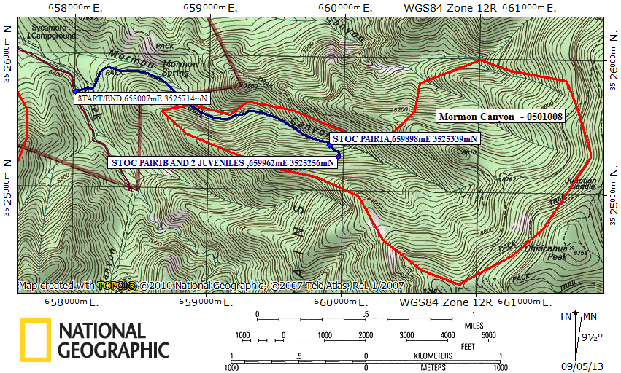
Red line = PAC boundary Blue line = path hiked

